History 280: United States Environmental History

Course Meetings: Tuesday and Thursday  12:30-1:45pm  165 CBB  Office Hours: Tuesday and Thursday 2-3pm | UWSP – History Department  473 CCC  Dr. Neil Prendergast  nprender@uwsp.edu
What can the past teach us about sustainability?

That question is at the root of all we’ll do this semester. As an historian, I teach how the past matters today. As an environmental historian, I believe that the lessons of the past should be environmental lessons.

In this class, we look for lessons to guide sustainability in three types of places: cities, farms, and forests. Each has its own development patterns, social problems, and ecological concerns. Getting to know them will give you a running start in addressing many of the environmental problems your generation will face. Your work in this course can prove useful for a number of careers, from forestry to urban planning to real estate to rural development, among much else. (It’s also just plain interesting.)

In each unit, we will keep in mind the components of sustainability: justice, economics, and ecology. As it turns out, Americans have long thought about these themes, well before the notion of sustainability came on the scene. That’s good for us, because it means we can learn from people who have already thought about the things we care about. The past is full of people who can help us decide how to build cities, farm soil, and manage forests.

Enduring Understandings:

Sustainability requires understanding the lessons of the past.

Learning Outcomes: After taking this course, students will be able to:

- Describe and explain major changes in the history of the United States environment
- Evaluate competing claims about the nation’s environmental past
- Question the landscape around them with thought and care

Course Structure and Assignments: To make our big sustainability question manageable, the course asks it within three units: Farm, Forest, and City.  Each unit ends with an exam. A Unit Study Guide will provide reading assignments (all of them available on Canvas), key terms, and the like. | 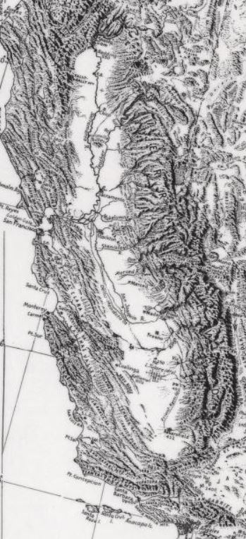
Advice from Previous Students: Why listen just to me? Here is what your predecessors want to tell you:

“Read the material and attend class.”

“Attend class, pay attention and from there it’s not hard to do well in the class.”

“Stay on top of the reading. It’s not too hard and the lectures cover the material, but the text gives a lot of depth and examples.”

“Involve yourself in the reading, thinking about how you could apply it to what you care about.”

“Be prepared to read! Pick up on little things.”

“Look beyond just the facts, because it is a very beneficial class.”

“Come to class and speak up. Participate. I found the class much more interesting when more people took part.”

Office Hours: You are welcome to visit me in my office. I set aside office hours so that I have the chance to talk with students one-on-one. From 2-3pm on Tuesday and Thursday, I do not have any other commitments. My only commitment is to speak with my students.

Readings: Our readings will be on Canvas as downloadable PDF’s. Each is a groundbreaking article or book chapter by a leading scholar.
Grading: 3 exams @ 25 points each + Final Paper @ 25 points = 100 semester points.

Letter grades for the semester follow the typical pattern:

A 93-100 | B+ 87-89.99 | C+ 77-79.99 | D+ 67-69.99 | F 59.99 and below
A- 90-92.99 | B 83-86.99 | C 73-76.99 | D 60-66.99
 | B- 80-82.99 | C- 70-72.99
Course Policies: During the class, cell phones and other electronic devices are prohibited. If you are a parent or are otherwise obligated to be available to your family via cell phone, then please discuss that situation with me, so I know that you have a good reason for keeping your phone turned on.

The prohibition of electronics also extends to laptop computers (unless approved by the Learning Technology Center). While laptops are great aides in studying, the focus in class is on class, not the computer screen. If you do prefer to have your notes in a computer file, you will find that typing them from your handwritten notes will aid you greatly in digesting the material.

For information on plagiarism, consult http://www.uwsp.edu/centers/rights. See Chapter 14, Student Academic Standards and Disciplinary Procedures, pages 5 -10, for the disciplinary possibilities if you are caught cheating. As an instructor deeply concerned with fairness in the classroom, I pursue each and every case of plagiarism and cheating. Please note that turnitin.com is used for the essay assignments.

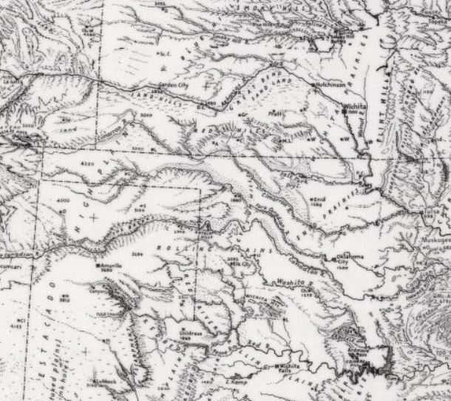 | Life Happens: I understand you have a life outside this class. I understand that life might make it difficult to complete some assignments, attend class, or simply to do well. I do my best to be flexible because I know those circumstances are out of your control and my control. I’m on your team.  I also know that some real learning has to take place in this class. You will have more opportunity in life if you understand history, read critically, and write well. This class has to be one of your priorities. I do my best to be flexible, but I have to adhere to some standards. If something comes up, let’s talk.
Equity of Educational Access: If you have a learning or physical challenge which requires classroom accommodation, please contact the UWSP Disability Services office with your documentation as early as possible in the semester. They will then notify me, in a confidential memo, of the accommodations that will facilitate your success in the course. Disability Services Office, 103 Student Services Center, Voice: (715) 346-3365, TTY: (715) 346-3362, http://www.uwsp.edu/special/disability/studentinfo.htm.

Schedule Readings are listed in the Unit Study Guides available in Canvas.
Introduction
Week 1 | Tuesday What is the promise of environmental history? | Thursday What is the best way to begin an environmental history of the United States?
FARM
Week 2 | Tuesday  What caused the near extinction of the bison? | Thursday  How did conquest transform the American landscape?
Week 3 | Tuesday  What caused the Dust Bowl? | Thursday  How did plantation slavery transform the environment?
Week 4 | Tuesday  How did Southerners outside plantations shape the landscape? | Thursday  How did fisheries develop in the United States?
Week 5 | Tuesday  How did California become the nation’s leading farm state? | Thursday  Exam
FOREST
Week 6 | Tuesday  How did New England settlement transform the region’s forests? | Thursday  What caused the destruction of the longleaf pine forest in the American South?
Week 7 | Tuesday  How did forest conservation begin? | Thursday  How did Great Lakes forests recover from logging?
Week 8 | Tuesday  How did tree farms develop in the U.S.? | Thursday  What were the 20th century politics of old growth logging?
Week 9 | Tuesday  How have Native people managed reservation forests? | Thursday  Exam
CITY
Week 10 | Tuesday  Why did New Orleans fare so poorly during Hurricane Katrina? | Thursday  How did Americans reform the industrializing city?
Week 11 | Tuesday  How did suburbanization transform the continent? | Thursday  Why is Portland such a green city?
Week 12 | Tuesday  Why do minorities suffer from greater pollution than white Americans? | Thursday  What is the history of alternative transportation?
Week 13 | Tuesday  How has recycling managed the problem of urban waste? | Thursday  Exam
Week 14 | Tuesday  Final Paper Introduction | Thursday  Final Paper Workshop
Week 15 | Tuesday  Final Paper Image Presentations | Thursday  Final Paper Image Presentations
Exam Week | Final Paper Due in Canvas by 10am, Tuesday, May 12.
NOTE: This syllabus is a general plan. Changes may be announced in class, via email, or on Canvas.

